Vision System
The vision subsystem provides visual localization support for the autonomous minesweeper robot by recognizing the reference letters (A–S) and numbers (1–19) located around the competition arena. These markers define the arena coordinates and help the robot estimate its position while navigating the field.
The system uses an HD camera to continuously capture images of the arena boundaries. Each image is processed using OpenCV to improve its quality through grayscale conversion, noise reduction, adaptive thresholding, and region of interest (ROI) extraction. These preprocessing steps reduce the effects of lighting variations and improve character visibility.

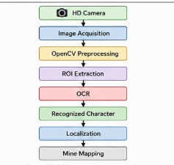
After preprocessing, the extracted character is recognized using Optical Character Recognition (OCR). The recognized letter or number is then transmitted to the robot controller, where it is used as a reference for localization and mine mapping. This information allows the robot to associate detected mines with the correct arena coordinates, improving the accuracy of the generated map.
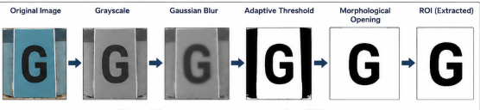
The OpenCV and OCR pipeline was selected because it provides reliable character recognition with low computational requirements, making it suitable for embedded robotic platforms without requiring model training.
Overall, the vision subsystem improves localization accuracy and supports reliable autonomous navigation and mine mapping throughout the competition arena.
